LAB 6.1

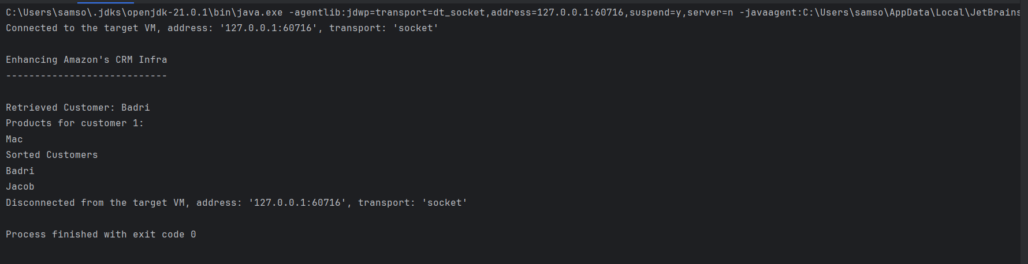

LAB 6.2